LABORATORY # 08

Amplification of a Signal at Low/High Frequencies Using BJTs

We have already discussed introduction in Lab # 7. Let starts with circuit.
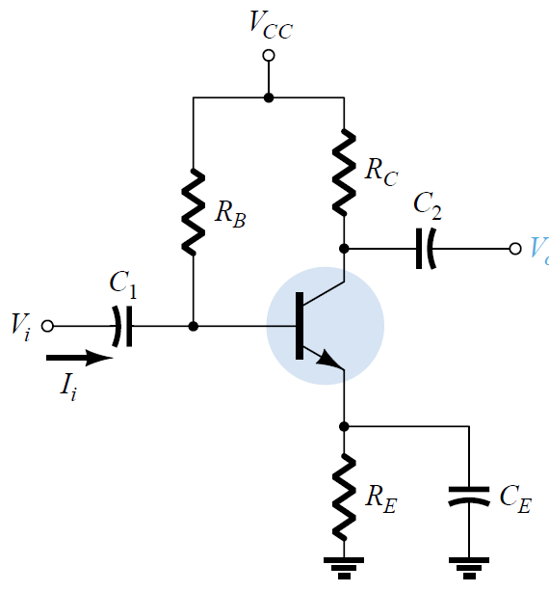
Figure 8.1 Common Collector Circuit
- Analyze the effect of Capacitor (C1, C2 and Ce) using 3.3uF, 1.0uF and 470uF. For each value of capacitor, apply the input signal with V=100mVpp at given range of frequencies (see Table 8.1) to the given circuit as shown in Fig. 8.1. Evaluate the behavior of an input signal with npn type BJT (2N3904/MPSA42). Use R_{B} = 15KΩ, R_{C}=1KΩ, R_{E}=1.5KΩ and V_{CC}=16V.
- Repeat part 1 for Vin=1Vpp
Procedure:
- Build the circuit as shown in Figure 8.1 in Multisim and amplify the input signal at given frequencies (Low/High) using BJT (2N3904/MPSA42).
- Build the circuit as shown in Figure 8.1 in Lab and amplify the input signal at given frequencies (Low/High) using BJT (2N3904/MPSA42).
- Complete Table 8.1 with your Multisim and experimental results.
- Attach input and output waveforms for both Multisim and experimental results.
- Discuss results in conclusion section. Analyze in terms of low/high value of capacitors
- Compare and discuss your results at Vin=100mV with Vin=1.0V.
- Compare amplification of a signal using BJT with respect to Op-Amp 741 (Lab 2).
- Draw the bandwidth graph based on your lab results for Vin=100mV and 1V.
Table 8.1
Frequency | Vout | Voltage Gain
10 | 22 mV | -19.17 dB
30 | 54.5 mV | -11.29 dB
60 | 75.9 mV | -8.41 dB
100 | 85.4 mV | -7.39 dB
200 | 93.7 mV | -6.59 dB
500 | 519 mV | 8.28 dB
1 KHz | 1.98 V | -1.57 dB
2 kHz | 4.88 V | 3.12 dB
5 KHz | 8.56 V | 8.67 dB
10 KHz | 9.19 V | 11.09 dB
15 KHz | 9.29 V | 11.74 dB
20 KHz | 9.31 V | 11.98 dB
50 KHz | 9.34 V | 12.25 dB
75 KHz | 9.35 V | 12.27 dB
100 KHz | 9.35 V | 12.26 dB
150 KHz | 9.33 V | 12.23 dB
200 KHz | 9.28 V | 12.17 dB
500 KHz | 9.34 V | 11.49 dB
750 KHz | 9.40 V | 10.61 dB
1 MHz | 9.31 V | 9.38 dB
1.5 MHz | 8.27 V | 7.62 dB
2.0 MHz | 8.53 V | 5.84 dB

100mV experimental
Frequency | Vout | Voltage Gain calculate later
10 | 44.15 mV | -19.17 dB
30 | 62.89 mV | -11.29 dB
60 | 95.71 mV | -8.41 dB
100 | 144.07 mV | -7.39 dB
200 | 283.91 mV | -6.59 dB
500 | 675.57 mV | 8.28 dB
1 KHz | 1.295 V | -1.57 dB
2 kHz | 2.33 V | 3.12 dB
5 KHz | 3.83 V | 8.67 dB
10 KHz | 4.19 V | 11.09 dB
15 KHz | 4.29 V | 11.74 dB
20 KHz | 4.31 V | 11.98 dB
50 KHz | 4.34 V | 12.25 dB
75 KHz | 4.36 V | 12.27 dB
100 KHz | 4.37 V | 12.26 dB
150 KHz | 4.39 V | 12.23 dB
200 KHz | 4.39 V | 12.17 dB
500 KHz | 4.33 V | 11.49 dB
750 KHz | 4.28 V | 10.61 dB
1 MHz | 4.21 V | 9.38 dB
1.5 MHz | 4.11 V | 7.62 dB
2.0 MHz | 3.98 V | 5.84 dB

1V experimental
Frequency | Vout | Voltage Gain calculate later
10 | 480.5 mV | -19.17 dB
30 | 624.5 mV | -11.29 dB
60 | 967.5 mV | -8.41 dB
100 | 1.47 V | -7.39 dB
200 | 2.73 V | -6.59 dB
500 | 4.50 V | 8.28 dB
1 KHz | 4.69 V | -1.57 dB
2 kHz | 4.71 V | 3.12 dB
5 KHz | 4.72 V | 8.67 dB
10 KHz | 4.73 V | 11.09 dB
15 KHz | 4.74 V | 11.74 dB
20 KHz | 4.74 V | 11.98 dB
50 KHz | 4.77 V | 12.25 dB
75 KHz | 4.78 V | 12.27 dB
100 KHz | 4.79 V | 12.26 dB
150 KHz | 4.81 V | 12.23 dB
200 KHz | 4.81 V | 12.17 dB
500 KHz | 4.72 V | 11.49 dB
750 KHz | 4.68 V | 10.61 dB
1 MHz | 4.63 V | 9.38 dB
1.5 MHz | 4.58 V | 7.62 dB
2.0 MHz | 4.48 V | 5.84 dB

